West P.S. Sites | Monday | Tuesday | Wednesday | Thursday | Friday
EarlyON Centre  86 Gibson St  Parry Sound  746-9522 | 9:30- 12:00 | Closed  In person Moms to Moms  9:30-12:00 | 9:30- 12:00 | Virtual Moms to Moms  1:00-2:00 | 9:30- 12:00
Humphrey Arena  15 Humphrey Drive  Seguin, ON P2A 2W8 | 10:00-12:00
Orrvillee Community Centre1207 Hwy. 518 |  |  | 9:30-12:00
Carling Community Centre  2 Carling Bay Rd,  Carling, ON P0G1G0 |  |  |  |  | 10:00-12:00
Foley Agricultural Hall  60 Rankin Lake Rd  Seguin, ON P2A 0B0 |  | 10:00-12:00
Rosseau Memorial Hall  2 Victoria St,  Rosseau | 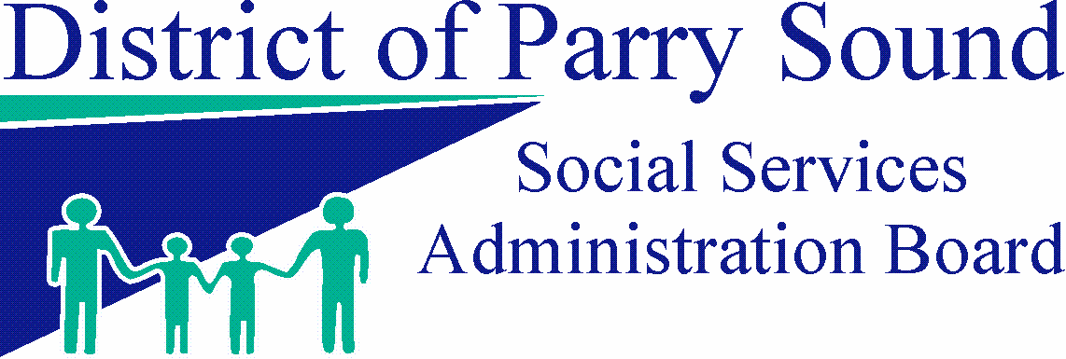 |  |  | 10:00-12:00
East P.S. Sites | Monday | Tuesday | Wednesday | Thursday | Friday
South River EarlyON  16 Toronto St.  South River  386-2552 | 9:00-12:00 | Closed | 9:00-12:00 | Closed | 9:00-12:00
Burks Falls  Land of Lakes Public School  92 Ontario St  P0A 1CO  472-7015 x 6318 | 9:00-12:00 | Closed | 9:00-12:00 | Closed | 9:00-12:00
Evergreen Heights School 2510 Hwy. 592  Emsdale, P0A 1J0 |  | 9:30-12:00
Kearney Community Centre 8 Main St.  P0A 1M0 |  |  |  | To be determined
Magnetawan Central School  31 Sparks St.  Magnetawan P0A1P0 |  | 10:00-12:00
Mapleridge School  171 Edward St.  Powassan  P0A 1Z0 |  | 10:00-12:00
Sundridge  Bethel Pentecostal Church  15 Buck Haven Rd  P0A 1ZO |  |  |  |  | 10:00-12:00
M.T. Davidson School  249 Lansdowne  Callander P0H 1H0 |  |  | 10:00-12:00
Argyle Public School  11767 Hwy.522  705-475-2316 |  |  |  | 10:00-12:00
Trout Creek Community Centre | 9:30-12:00

For more information call: 705-746-9522 or 1 866-850-8855 ext 4300, or 705-386-2552 or 1-866-850-8855 ext 5452
operated by the District of Parry Sound Social Services Administration Board July 2023

