Accommodation Verification 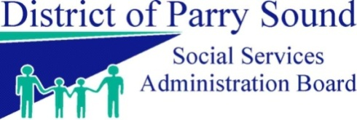
Part 1: To be completed by the tenant, please print.
Name: | Member ID:
New Street Address: | Caseworker:
Apartment /Box#: | Phone#:
City/Town: | Postal Code:
Pay Direct Authorized by Tenant:
Yes No
This authorization does not affect, in any way, my responsibilities or obligations as a tenant as set out in the Commercial Tenancies Act and the Residential Tenancies Act, 2006.

Part 2 & 3: To be completed by landlord, owner or superintendent
Landlord Name and Address: |  |  | Do you own the building/property:  Yes No
Phone #:
Work #:
Landlord Email:  **To communicate when a pay direct is no longer eligible |  |  | Are you a parent/relative of the tenant:  Yes No
Part 3: Rental Information - To be completed by landlord, owner or superintendent

Accommodation type:  Room Apartment House Use of House |  |  | Date of Occupancy:
Is this a shared accommodation?  Yes No | If Yes, with whom? (List all persons residing at the address)
 | If Yes, Total Rent Amount for the Accommodation:
Rental Amount paid by tenant each month: |  | Is Hydro Included? | Yes No
 |  | Is Heat Included? | Yes No
 |  | Is Water/Sewage Included? | Yes No
 |  | Is Food Included? | Yes No
Pay Direct Requested by Landlord:
Yes No
Disclaimer: Please be advised that this Accommodation Verification form does not constitute a contractual agreement of any kind between the landlord and the District of Parry Sound Social Services Administration Board. This form is for verification of rental information only. There is no guarantee that the Pay Direct rent payment will be issued each month as it is dependent on the continued eligibility of the Ontario Works Client. Please note that any damages incurred or arrears owing is the responsibility of the tenant.

______________________________ ______________________________
Tenant Signature Date

_______________________________ ______________________________
Landlord Signature Date

